Lagged cross-correlation: AUDUSD and EURGBP
Method 12 / daily log returns / K_max=10 / Alpari D1 full available history

Study setup
Logical pair: AUDUSD , EURGBP
Broker symbols: AUDUSD_i , EURGBP_i
Snapshot: 2026-11-03_majors_alpari_D1
Timeframe: D1
Matched return window: 1999-01-06 to 2026-11-02 (UTC bar dates)
Matched return count n: 7198
Dropped unfinished last bar dated 2026-11-03 UTC after a tick-volume check against the prior complete day.
Lag definition: rho_X->Y(k) = Corr(x_t, y_{t+k}) on matched D1 bars
K_max = 10; headline lag k = 1 (both directions)
Complete matched rows (Excel): AUDUSD-EURGBP_Lagged_D1.xlsx
Complete matched rows (HTML table): AUDUSD-EURGBP_Lagged_D1_data.html

Method carried forward
Lagged cross-correlation measures Pearson correlation between matched daily log returns of close, ln(close_t / close_t-1), after shifting one series forward by k bars on the matched panel. Quotes are not inverted. rho_{X->Y}(k) = Corr(x_t, y_{t+k}) with n_k = n - k. K_max = 10 is fixed before estimation. The headline is the pre-specified lag k = 1 in both directions. k = 0 is the same-bar side check. The lag inside 1..10 with the largest absolute rho is stored as a descriptive column only; it is not a selected result. This is a linear screen, not proof of forecast edge, economic cause, or a trading signal.

Results (headline k=1)
rho_AUDUSD->EURGBP(1): -0.031475 (n=7197)
95% Fisher interval AUDUSD->EURGBP: [-0.054539, -0.008377]
rho_EURGBP->AUDUSD(1): -0.009732 (n=7197)
95% Fisher interval EURGBP->AUDUSD: [-0.032828, 0.013375]
Same-bar rho(k=0): 0.038173
Largest |rho| among k=1..10 (descriptive only, not selected): AUDUSD->EURGBP k=1 rho=-0.031475; EURGBP->AUDUSD k=4 rho=0.037876

CCF table
k | rho_AUDUSD_to_EURGBP | n_AUDUSD_to_EURGBP | rho_EURGBP_to_AUDUSD | n_EURGBP_to_AUDUSD
0 | 0.03817331 | 7198 | 0.03817331 | 7198
1 | -0.03147511 | 7197 | -0.00973169 | 7197
2 | -0.02193169 | 7196 | 0.00786318 | 7196
3 | 0.00655744 | 7195 | -0.00779186 | 7195
4 | 0.01106871 | 7194 | 0.03787597 | 7194
5 | 0.01415508 | 7193 | 0.01278943 | 7193
6 | -0.00928916 | 7192 | 0.03451612 | 7192
7 | -0.00354159 | 7191 | 0.00769816 | 7191
8 | -0.0248178 | 7190 | 0.0260082 | 7190
9 | -0.03034967 | 7189 | 0.00417397 | 7189
10 | 0.01475299 | 7188 | 0.0285686 | 7188

Conclusion
At the pre-specified lag k=1 for AUDUSD and EURGBP, rho_{AUDUSD->EURGBP}(1) = -0.0315 (n=7197) and rho_{EURGBP->AUDUSD}(1) = -0.0097 (n=7197). Same-bar rho(k=0) = 0.0382. Largest |rho| among k=1..10 is descriptive only: AUDUSD->EURGBP at k=1 (-0.0315); EURGBP->AUDUSD at k=4 (0.0379). This is a linear screen, not forecast proof or a trading signal.

Charts
Daily closes

Daily log returns

CCF both directions k=0..10
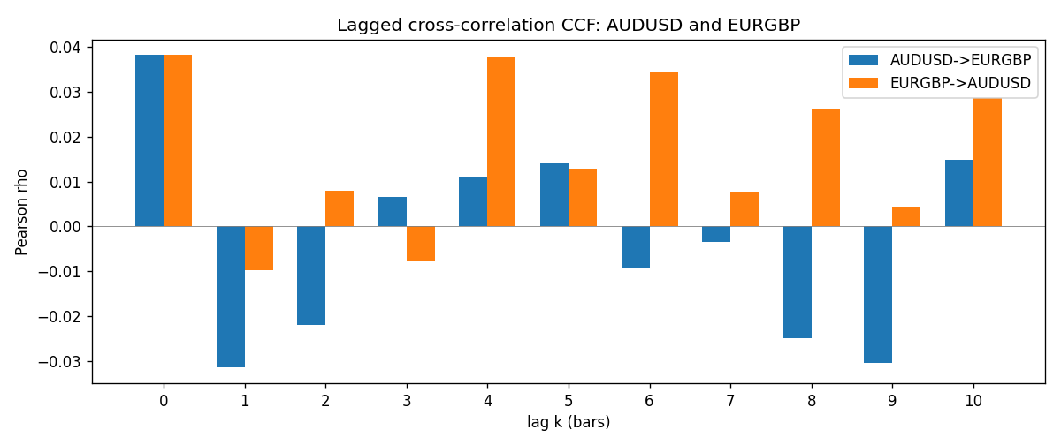

Data report
Every matched row is stored in the sibling Excel workbook named AUDUSD-EURGBP_Lagged_D1.xlsx (sheet matched_rows). The CCF sheet holds rho(k) for k=0..10. Embedding all rows as a Word table is impractical; the Word file holds column summaries and the first and last 15 rows.
Columns: time, AUDUSD_open, EURGBP_open, AUDUSD_high, EURGBP_high, AUDUSD_low, EURGBP_low, AUDUSD_close, EURGBP_close, AUDUSD_tick_volume, EURGBP_tick_volume, AUDUSD_spread, EURGBP_spread, AUDUSD_real_volume, EURGBP_real_volume, AUDUSD_log_return, EURGBP_log_return
Column summaries (matched calculation rows)
column | count | mean | std | min | 25% | 50% | 75% | max
AUDUSD_open | 7198 | 0.75202191 | 0.13526259 | 0.4785 | 0.6611175 | 0.731685 | 0.8091425 | 1.10284
EURGBP_open | 7198 | 0.78667202 | 0.09675257 | 0.5734 | 0.687325 | 0.83369 | 0.8651775 | 0.9769
AUDUSD_high | 7198 | 0.7560731 | 0.13582215 | 0.4878 | 0.6648025 | 0.7351 | 0.8153975 | 1.10795
EURGBP_high | 7198 | 0.7897492 | 0.09712763 | 0.5789 | 0.6894 | 0.836595 | 0.86804 | 0.9799
AUDUSD_low | 7198 | 0.74796393 | 0.1345766 | 0.4775 | 0.6578225 | 0.727775 | 0.804275 | 1.0975
EURGBP_low | 7198 | 0.7839722 | 0.09657024 | 0.5682 | 0.6853 | 0.831475 | 0.8627775 | 0.9661
AUDUSD_close | 7198 | 0.75206897 | 0.13524509 | 0.4786 | 0.661255 | 0.7318 | 0.8092725 | 1.10169
EURGBP_close | 7198 | 0.78671595 | 0.09675201 | 0.5735 | 0.687525 | 0.83375 | 0.865285 | 0.977
AUDUSD_tick_volume | 7198 | 77378.184 | 138156.24 | 109 | 5445.75 | 43349.5 | 71356.75 | 1234623
EURGBP_tick_volume | 7198 | 86961.088 | 145396.59 | 332 | 6520.25 | 44270 | 81329 | 1424684
AUDUSD_spread | 7198 | 30.809114 | 16.88495 | 0 | 13 | 30 | 50 | 50
EURGBP_spread | 7198 | 21.389692 | 19.14164 | 0 | 4 | 13 | 50 | 50
AUDUSD_real_volume | 7198 | 5.2442754e+09 | 1.2540657e+11 | 0 | 0 | 0 | 0 | 3.811512e+12
EURGBP_real_volume | 7198 | 2.7809077e+10 | 1.3507993e+11 | 0 | 0 | 0 | 0 | 3.5726265e+12
AUDUSD_log_return | 7198 | 2.054e-05 | 0.00754782 | -0.08602525 | -0.00386556 | 0.00027727 | 0.00415374 | 0.0806166
EURGBP_log_return | 7198 | 2.199e-05 | 0.00487197 | -0.03067367 | -0.00262256 | -0.00010006 | 0.00256155 | 0.06075387
First 15 matched rows (selected columns)
time | AUDUSD_close | EURGBP_close | AUDUSD_log_return | EURGBP_log_return
1999-01-06 | 0.6289 | 0.7019 | 0.011836351 | -0.013303338
1999-01-07 | 0.6345 | 0.7097 | 0.0088650256 | 0.011051402
1999-01-08 | 0.6347 | 0.7062 | 0.00031515916 | -0.004943862
1999-01-11 | 0.6393 | 0.7053 | 0.0072213815 | -0.0012752393
1999-01-12 | 0.6362 | 0.7077 | -0.0048608485 | 0.0033970309
1999-01-13 | 0.6312 | 0.708 | -0.0078902098 | 0.00042381861
1999-01-14 | 0.6295 | 0.7066 | -0.002696916 | -0.0019793588
1999-01-15 | 0.634 | 0.7012 | 0.007123101 | -0.0076715819
1999-01-18 | 0.6346 | 0.7017 | 0.00094592471 | 0.00071280921
1999-01-19 | 0.6392 | 0.7007 | 0.0072225153 | -0.0014261269
1999-01-20 | 0.64 | 0.7021 | 0.0012507819 | 0.0019960086
1999-01-21 | 0.6405 | 0.7016 | 0.00078094498 | -0.00071240297
1999-01-22 | 0.6327 | 0.7004 | -0.012252745 | -0.0017118406
1999-01-25 | 0.6302 | 0.6966 | -0.0039591468 | -0.0054402425
1999-01-26 | 0.6305 | 0.6962 | 0.00047592608 | -0.00057438255
Last 15 matched rows (selected columns)
time | AUDUSD_close | EURGBP_close | AUDUSD_log_return | EURGBP_log_return
2026-10-13 | 0.69821 | 0.84458 | 0.0035007712 | 0.00020130374
2026-10-14 | 0.69715 | 0.84553 | -0.0015193215 | 0.0011241873
2026-10-15 | 0.69191 | 0.84479 | -0.0075447063 | -0.00087557391
2026-10-16 | 0.69426 | 0.84307 | 0.0033906408 | -0.0020380844
2026-10-19 | 0.6978 | 0.84259 | 0.0050859986 | -0.00056950988
2026-10-20 | 0.70022 | 0.83957 | 0.0034620426 | -0.0035906254
2026-10-21 | 0.70275 | 0.83839 | 0.0036066384 | -0.00140647
2026-10-22 | 0.70186 | 0.83682 | -0.0012672558 | -0.0018743924
2026-10-23 | 0.70353 | 0.83751 | 0.0023765656 | 0.00082421033
2026-10-26 | 0.70128 | 0.83762 | -0.0032032829 | 0.00013133309
2026-10-27 | 0.70245 | 0.83595 | 0.0016669876 | -0.0019957343
2026-10-28 | 0.70533 | 0.83651 | 0.0040915541 | 0.00066967224
2026-10-29 | 0.70245 | 0.83553 | -0.0040915541 | -0.0011722209
2026-10-30 | 0.70316 | 0.83351 | 0.0010102376 | -0.0024205543
2026-11-02 | 0.69971 | 0.83426 | -0.0049184984 | 0.00089940465

